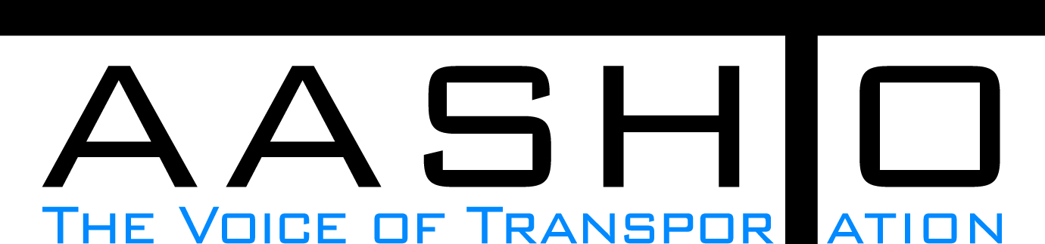Domestic Scan Proposal Form
AASHTO is soliciting topic proposals for a Calendar Year 2013 US Domestic Scan Program (NCHRP Panel 20-68A). Each selected scan topic will be investigated through site visits to three to six locations for approximately a two week period or less (type 1), by webinar (type 2) or peer exchange (type 3) conducted by a group of eight to 12 transportation professionals with expertise in the selected topic area. Proposed topics should meet the following criteria:
- Address an important and timely need for information by transportation agencies;
- Are of interest to a broad national spectrum of people and agencies;
- Are complex and also “hands-on,” meaning they lend themselves particularly well to exploration through on-site visits; and
- Are sufficiently focused that the tour participants are able to investigate and understand key issues in the limited time available on the tour.
This form is designed to collect the full length of your proposal. Sections requiring essays have unlimited space for you to use. Contact information has some limited text. Use your TAB key to advance to the area where you need to complete information.
Proposals should be returned no later than OCTOBER 15, 2012.
Proposal Contact Information
Name | Meredith Dahlrose | Address | 605 Suwannee St.  Tallahassee, FL 32399
Title | Seaports Coordinator | E-mail | Meredith.Dahlrose@dot.state.fl.us
Member Department | Florida Department of Transportation | Telephone number | (850) 414-4551
AASHTO Committee |  | Date of submission | 10/12/2012

Title of Proposed Scan

Assessing Relative Competencies of Integrated Logistic Centers/Inland Ports versus Expanded Dockside Operations

Problem Statement (What topic is to be examined? What drives the need for the scan? Why now?)
Freight transportation by cargo ship is expected to change considerably in the near future as the Panama Canal expansion is completed. Larger container ships could bring both increased cargo volumes and the potential for a new optimal logistical freight paradigm.
Two competing strategies to improve port capabilities have been deployed around the United States; increasing dockside capabilities for warehousing and modal transfer, or construction of inland ports to house these facilities. The benefits of one strategy over the other likely vary by the type of freight, the origin and destination of the freight, and modal options available, however there has yet to be a national effort to showcase these benefits as experienced at the port facilities currently employing them.
Investigating the relative competencies of these strategies would benefit not only port operators and shippers, but state Departments of Transportation as well. MAP21 has identified “Freight Movement and Economic Vitality” as a performance measure for individual states, therefore supplying states with tools to improve freight movement will be of increasing importance.

Scan Scope (What specific subject areas are to be examined? Which cities and states might be visited? Which agencies/organizations (including specific departments or types of staff if applicable)?
It is proposed that a domestic scan be conducted to analyze large ocean ports that have either linked to inland ports, or expanded their dockside capabilities. Specific attributes to investigate include contributors to the decision process for choosing one option over the other, relative advantages, best practices for design and operation of both options, and optimal logistics chains.

Potential facilities to visit for this scan include inland ports of Front Royal, VA, Raritan, NJ, and Dallas TX, and ocean ports that have expanded their warehousing and modal transfer capabilities such as Savannah, GA and the Virginia Ports Authority. Additional ports could be included.

Anticipated Scan Results (What key information is to be gained? What information is to be shared after the scan? Who would the audience be for this information?)
The information gained in this scan would be of use to state run, municipal, and private ocean ports considering changing their operational practices as the Panama Canal expands. Additionally, state DOTs will use this information in preparation to meet MAP21 freight movement requirements. A comprehensive report detailing the observations made during scan visits would be an appropriate vehicle for dissemination.

Benefits Expected (Including potential impacts on current technology or procedures)
Optimized freight movement has the ability to create jobs, reduce consumer prices, decrease congestion, and to avoid unnecessary port expenditures on ineffective improvements.

